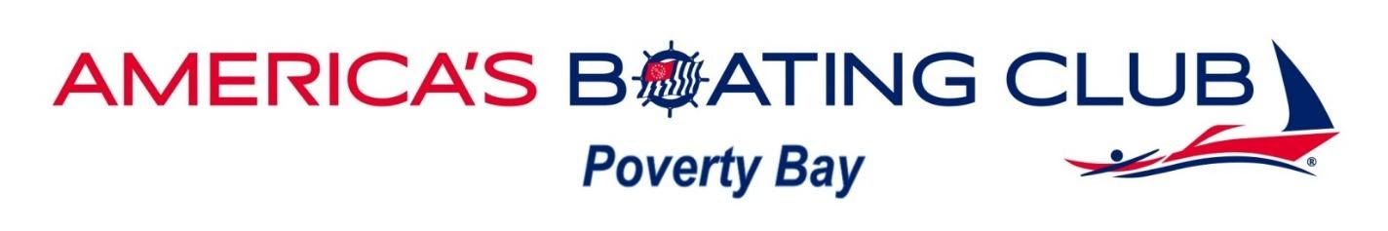

**USPS Engine Maintenance Course**

**When: Wednesdays 7:00 to 9:00 January 8th through March 4rd, 2020**

**Where: Des Moines Public Works Class Room               2255 S 223rd street.     Des Moines WA 98198**

**Instructor: Gene Kautzman, Rick Mortensen, and Dan Leenhouts**

This course covers the engine basics and routine maintenance on gas and diesel engines as well as a look at inboard, out board and I/O drive units.  A common-sense approach to troubleshooting and preventive maintenance. We will have some expert guest speakers from the local marine maintenance shop speak to us.

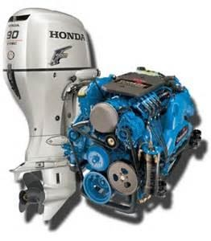

**Contact Dan Leenhouts** education@pbps.org

**Cost $60.00. If you want to share a book with someone very close. They may also attend the course for only $20.00.  So, two for $80.00**